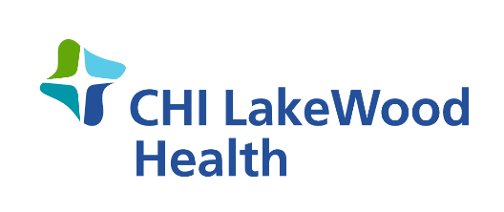

FOR IMMEDIATE RELEASE
Date: March 3rd, 2021
CHI LakeWood Health COVID-19 Vaccine Update
CHI LakeWood Health is excited to report that as of Wednesday, March 3rd, 2021 Lake of the Woods County has vaccinated 69% of residents who are 65 and older.
“Vaccine administration has been our top priority since the Emergency Use Authorizations of both Pfizer and Moderna and today we couldn’t be more proud of our team’s efforts and the vaccination rate for our county,” says Jeffry Stampohar, President of CHI LakeWood Health. “It has been a team effort with our Public Health Department and other community partners such as Thrifty White Pharmacy to ensure we are getting the vaccine out to our community.”
Minnesota (MN) Governor Tim Walz announced last week that MN will remain focused on vaccinating most of the state’s seniors before expanding eligibility for the COVID-19 vaccine. The guidance states that MN is to vaccinate 70% of adults age 65 and older before expanding eligibility, with hopes to reach this goal by the end of March. As of Wednesday, March 3rd, 2021 the state as a whole is at 54%.
With Lake of the Woods County close to reaching the 70% goal, CHI LakeWood Health is anticipating a decrease in weekly vaccine allocations as distribution will be focused on those areas who are below 70% for age 65 and older.
“Even though we are anticipating a decrease in our weekly vaccine allocations, we remain committed and are eager to move into the next phase of vaccinations as soon as the state releases the guidance,” says Stampohar. “In the meantime I want to commend our staff for the work they have done this far.”
Vaccines are just one tool in our toolkit to prevent the spread of COVID-19. It is important that we continue to follow CDC guidelines, which include wearing a mask, social distancing and frequent hand hygiene. For questions in regards to the COVID-19 vaccine please call CHI Lakewood Health’s COVID-19 navigator at 218.634.3457.
CHI LakeWood Health has been an integral part of the Baudette community since 1950. The campus includes a 15-bed acute-care Critical Access Hospital, a Skilled Nursing Facility, a family-practice Rural Health Clinic and a 10-unit Senior Living Facility. LakeWood offers a variety of medical services including: Cardiac Rehab, Behavioral Health, Public Health, Physical and Occupational Therapies, Telemedicine, Visiting Nurse and Ambulance Services. LakeWood is a member of CommonSpirit Health, a faith-based national health care system which was formed in February 2019 through the merger of Catholic Health Initiatives and Dignity Health.

###
Contact: Carrie Davidson
Email: carriedavidson@catholichealth.net
Phone: (218)634-3454

