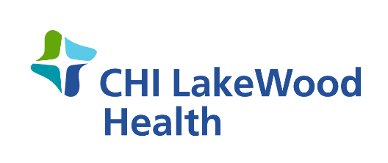

FOR IMMEDIATE RELEASE
Date: January 21, 2021
CHI LakeWood Health COVID-19 Vaccine Administration
At CHI LakeWood Health, it is our priority to administer COVID-19 vaccines as quickly and safely as possible. Vaccine eligibility is determined by federal and state guidelines, and state and local health departments determine how vaccines are distributed. LakeWood’s Public Health is participating in the administration of COVID-19 vaccines according to the Minnesota Department of Health’s guidelines for distribution.
Recently, the State opened up their guidelines to now include any one age 65 and older, educators and child care workers. To accommodate these individuals, the State has launched a pilot program with nine pilot sites across the state. These pilot sites are currently only serving adults 65 years of age and older, educators (prekindergarten through grad 12), school staff and child care workers. The pilot sites are located in: Andover, Brooklyn Center, Fergus Falls, Marshall, Mountain Iron, North Mankato, Rochester, St. Cloud and Thief River Falls. Please do not visit the vaccination pilot site unless you have scheduled an appointment. More information can be found online at Find My Vaccine: https://mn.gov/covid19/vaccine/find-vaccine/index.jsp
“Right now, LakeWood is focused on ensuring all eligible 1a individuals (health care workers and employees and residents of long-term care) have received their vaccine and are moving into the next phase,” says Kay Schell, CHI LakeWood Health Public Health Nurse. “Minnesota is currently only receiving 60,000 doses of the vaccine per week. Lake of the Woods County is being allotted doses based on our county size and positivity rate.”

With the current allocations LakeWood does not have enough doses to administer to all who qualify, but will continue to administer as the allotted doses are received. To be proactive in our prioritization and planning efforts, if you are age 65 and older or an essential worker, please call 218.634.5314 to be screened and placed on a vaccine wait list. Please only call if you meet this criteria. There are still gray areas around who is considered an essential worker. Essential workers are those deemed necessary to continue to provide for the health and safety of the residents of our community. LakeWood appreciates your patience as the vaccine administration process and guidance is a fluid situation.

“With an increase in recent confirmed positive cases for Lake of the Woods County, we need to remember that the vaccine is only one tool for fighting COVID-19. It is important that we continue to follow CDC guidelines, which include wearing a mask, social distancing and frequent hand hygiene even after you are vaccinated,” says Kay.

CHI LakeWood Health has been an integral part of the Baudette community since 1950. The campus includes a 15-bed acute-care Critical Access Hospital, a Skilled Nursing Facility, a family-practice Rural Health Clinic and a 10-unit Senior Living Facility. LakeWood offers a variety of medical services including: Cardiac Rehab, Behavioral Health, Public Health, Physical and Occupational Therapies, Telemedicine, Visiting Nurse and Ambulance Services. LakeWood is a member of CommonSpirit Health, a faith-based national health care system which was formed in February 2019 through the merger of Catholic Health Initiatives and Dignity Health.

###
Contact: Carrie Davidson
Email: carriedavidson@catholichealth.net
Phone: (218)634-3454

