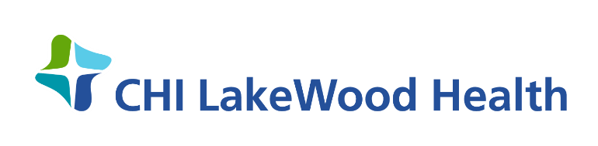

FOR IMMEDIATE RELEASE
Date: December 18, 2020
CHI LakeWood Health Begins Vaccinating Health Care Workers for COVID-19
CHI LakeWood Health began administering the Pfizer COVID-19 vaccine to health care workers on Friday, December 18th, 2020. The hospital is set to administer all 70 doses to health care workers by December, 22nd.
Minnesota is using a hub model for vaccine distributions, with 25 locations selected around the state that have sufficient cold storage. Sanford Health in Bemidji was identified as the hub for the northwest region of Minnesota, which includes Lake of the Woods County.
Per guidance from the Centers for Disease Control (CDC) and the Minnesota Department of Health (MDH), the first dose of the COVID-19 vaccine should be given to people working in hospitals and health care settings and to residents of long-term care facilities. CHI LakeWood Health expects to receive more doses in the near future, and has plans to vaccinate long-term care residents and staff on Monday, December 28th in coordination with Thrifty White Pharmacy.
MDH is also working with local public health to provide vaccines for essential personnel and at risk populations in Lake of the Woods County. “I’d expect to see the Moderna COVID-19 vaccine arrive in January for these populations,” says Kay Schell Public Health Nurse at CHI LakeWood Health. “If vaccine distribution continues as scheduled, we could expect to see it available to the broader public as early as Spring 2021.”
Jeffry Stampohar, President of CHI LakeWood Health, said, “Friday was a momentous day, full of emotion and joy. Much preparation went in to receiving and administering the vaccine and our team continues to push through and accomplish great things. As we move forward with the vaccine, it is still important that we continue to follow CDC guidelines. Please remember to wash your hands regularly, always wear face coverings in public, and follow social distancing guidelines and quarantine recommendations.”
CHI LakeWood Health has been an integral part of the Baudette community since 1950. The campus includes a 15-bed acute-care Critical Access Hospital, a Skilled Nursing Facility, a family-practice Rural Health Clinic and a 10-unit Senior Living Facility. LakeWood offers a variety of medical services including: Cardiac Rehab, Behavioral Health, Public Health, Physical and Occupational Therapies, Telemedicine, Visiting Nurse and Ambulance Services. LakeWood is a member of CommonSpirit Health, a faith-based national health care system which was formed in February 2019 through the merger of Catholic Health Initiatives and Dignity Health.
###

Carrie Davidson
218-634-3454
carriedavidson@catholichealth.net

